# **Cloud Native application Architecture**

Designing, building and running applications optimized for cloud computing environments.

Scalable, resilient and flexible applications for faster innovation and market responsiveness.

**Cloud-Native -**

* Approach for building, running and deploying modern applications
* Designed specifically for cloud environments
* Focus on scalability, resilience and flexibility

**Benefits of Cloud-Native -**

* Rapid innovations and response to market changes
* Modern tools and techniques for application development
* Frequent updates without impacting service delivery

**Speed and Agility in Business -**

* Business systems are strategic tools for growth
* Users demand for rapid responsiveness, innovative features and zero downtime
* Cloud-native systems handle rapid change, large scale and resilience

**Characteristics of Cloud Native Applications**

* Loosely coupled components
* Optimized for cloud performance
* Use of managed services provided by cloud vendors
* Continuous delivery methodology

## **Pillars of Cloud Native Applications**

|  |  |
| --- | --- |
| * Microservices * Containers * Orchestration * DevOps Practices * Automation and CI-CD * Scalability * Resilience * Observability |  |

CNCF Definition -

## **Application Architecture Journey**

## **Cloud-Native Pillars**

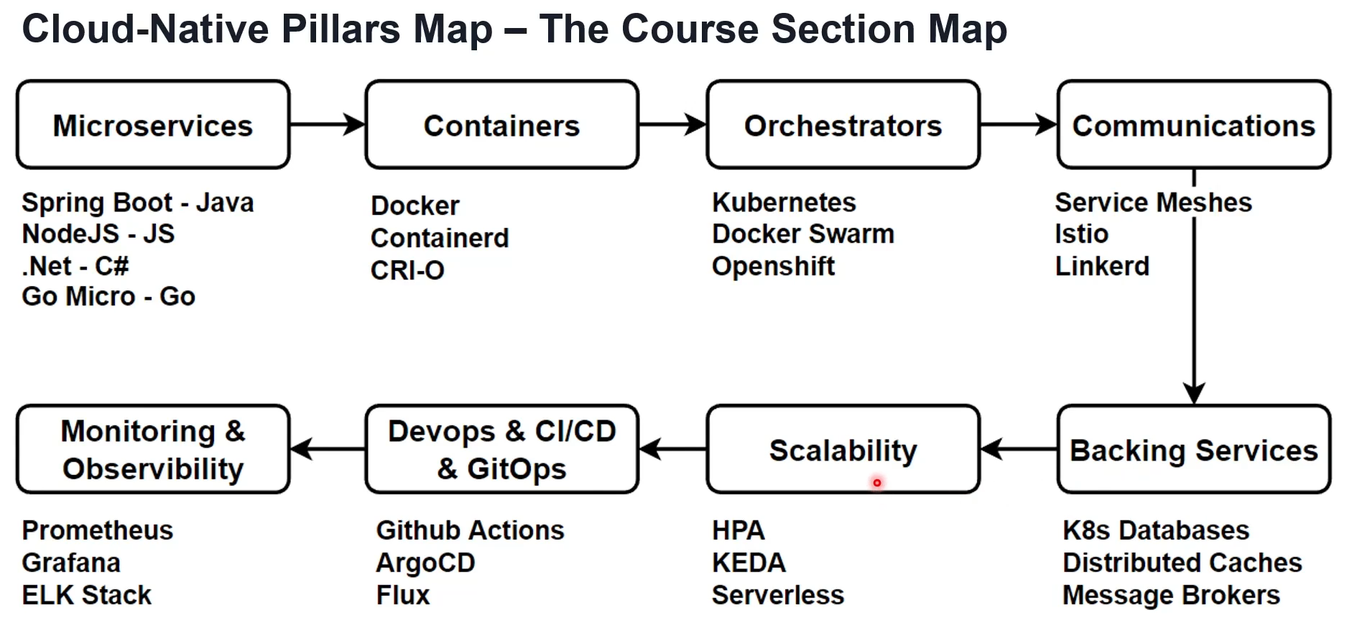

## **Cloud Native tools and Technology**

